Assignment 4_ 1

1.print sum of two numbers.

*/

public class acad {

public static void main(String[] args) {

int a;

int b;

int c;

a = 10;

b = 15;

c = a + b;

System.out.println("sum is : " + c );

}

}

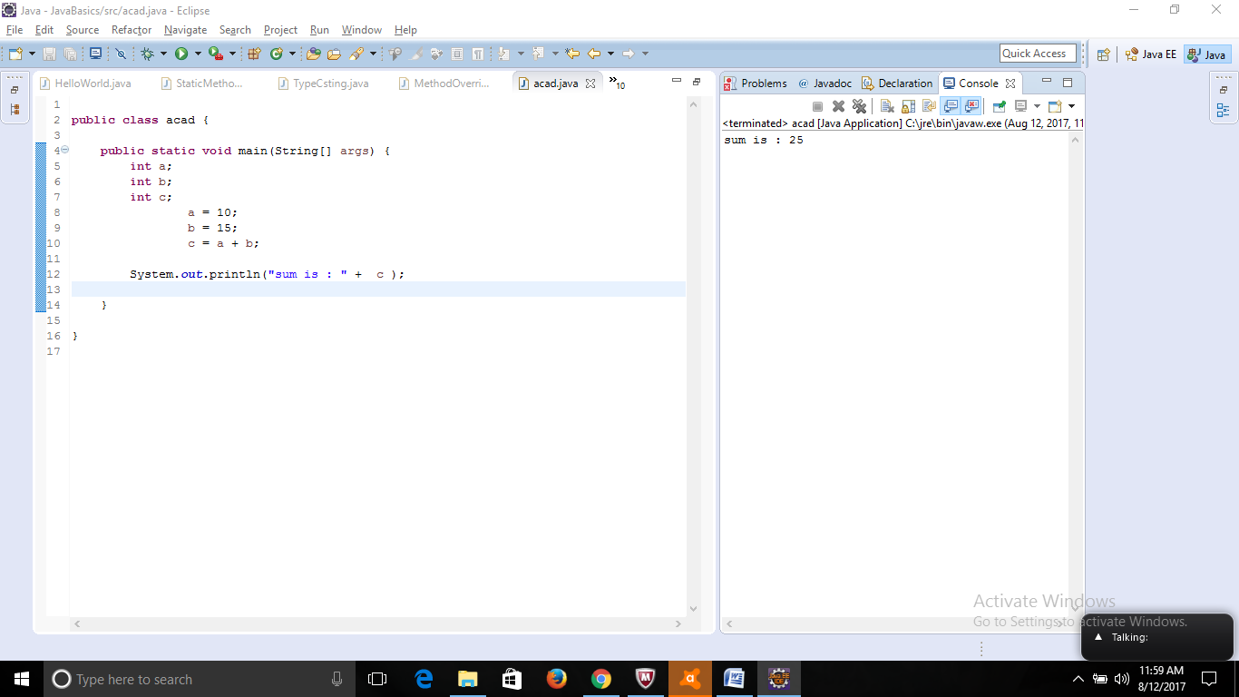

2. Accept input at runtime.

importjava.util.Scanner;

public class acad {

public static void main(String[] args) {

int c;

Scanner scan = new Scanner(System.in);

System.out.println("Enter value for a : " );

int a = scan.nextInt();

System.out.println("Enter value for b : " );

int b = scan.nextInt();

c = a + b;

System.out.println("sum of " + a + "and " + b + "is : " + c );

}

}

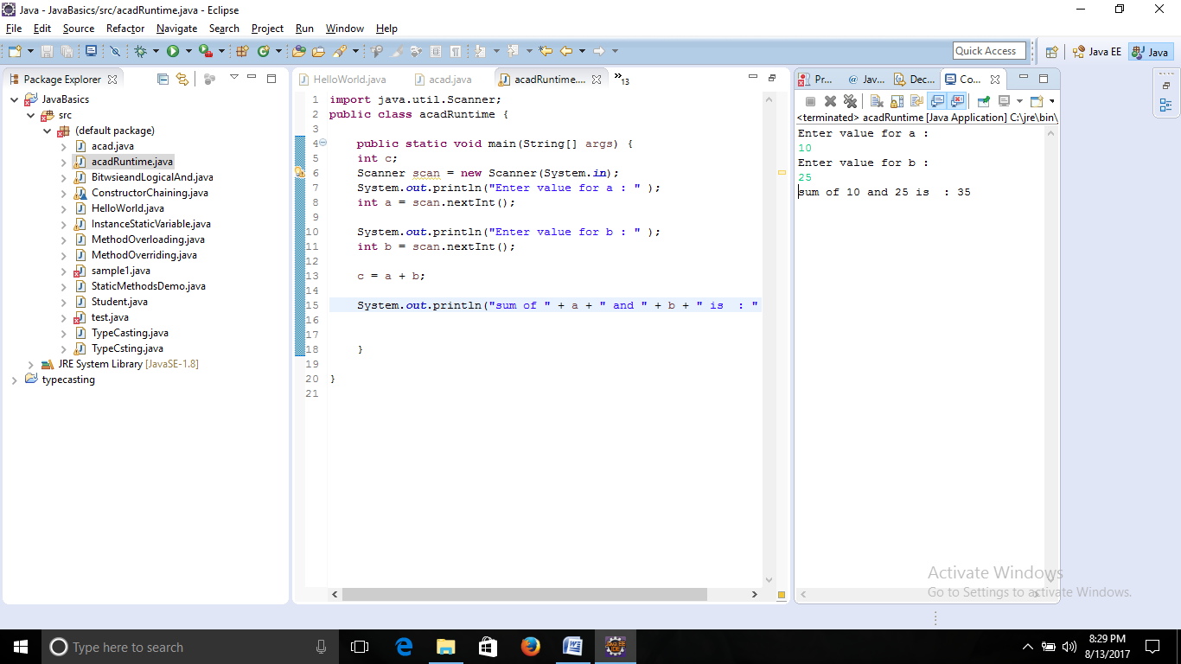

3. Write a program with method name SUM

Import java.util.Scanner;

public class acad {

private static int Sum(int x , int y){

return(x + y);

}

public static void main(String[] args) {

Scanner scan = new Scanner(System.in);

System.out.println("Enter value for a : " );

int a = scan.nextInt();

System.out.println("Enter value for b : " );

int b = scan.nextInt();

System.out.println("First Number is " + a );

System.out.println("Second Number is " + b );

System.out.println("Sum is " + Sum(a,b));

}

}

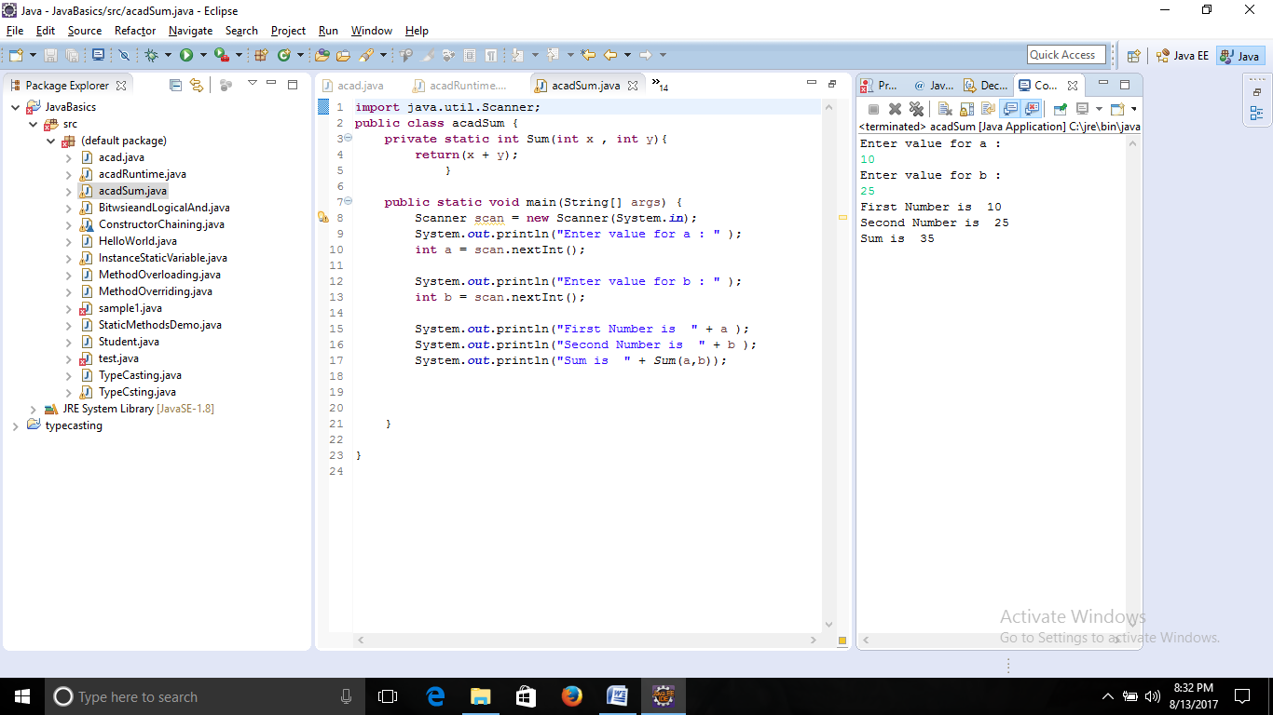

4. Write a program to accept two numbers from stdin and find all the odd and even numbers present in between them.

importjava.util.Scanner;

public class acad {

public static void main(String[] args) {

Scanner scan = new Scanner(System.in);

System.out.println("Enter value for a : " );

int a = scan.nextInt();

int o = 0;

int e =0;

System.out.println("Enter value for b : " );

int b = scan.nextInt();

int [] EvenNumber = new int[b];

int [] OddNumber = new int[b];

for (inti = a;i< b + 1;i ++){

if ((i % 2) == 0)

{

EvenNumber[e] = i;

System.out.println("EVEN :"+EvenNumber[e]);

e = e + 1;

}

else

{

OddNumber[o] = i;

System.out.println("ODD :"+i);

o = o + 1;

}

}

System.out.println("LIST OF EVEN NUMBERS BETWEEN " + a + " AND " + b + ":");

for (e = 0;e <EvenNumber.length;e++){

System.out.println(EvenNumber[e]);

}

System.out.println("LIST OF ODD NUMBERS BETWEEN " + a + " AND " + b + ":");

for (o = 0;o <OddNumber.length;o++){

System.out.println(OddNumber[o]);

}

}

}

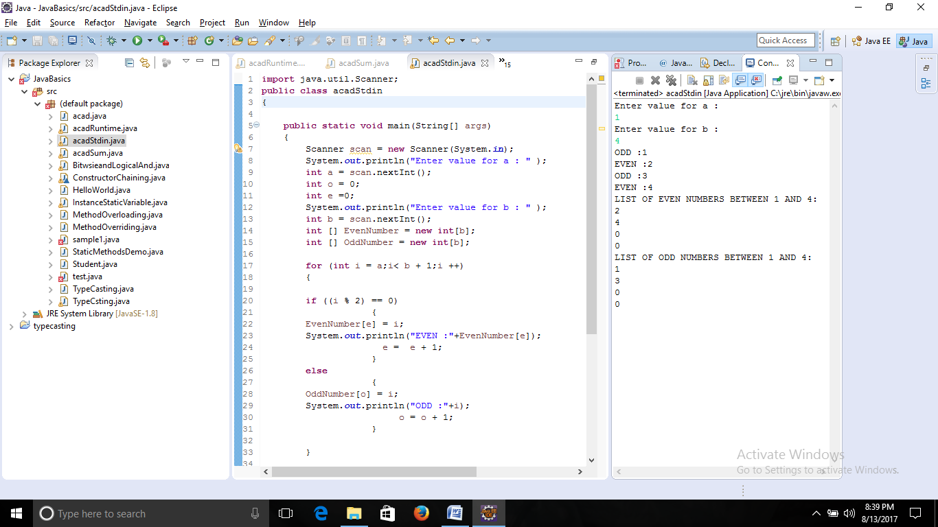

5. Program to show Multiples of 10 for a given input

importjava.util.Scanner;

public class MultipleTen {

public static void main(String[] args) {

Scanner scan = new Scanner(System.in);

System.out.println("Enter value for which multiple of 10 has to be obtained : " );

int a = scan.nextInt();

System.out.println("Input : "+ a);

System.out.println("Output ");

for (inti = 1;i < 11 ;i ++){

System.out.println( a + " * " + i+ " = " + a*i);

}

}

}

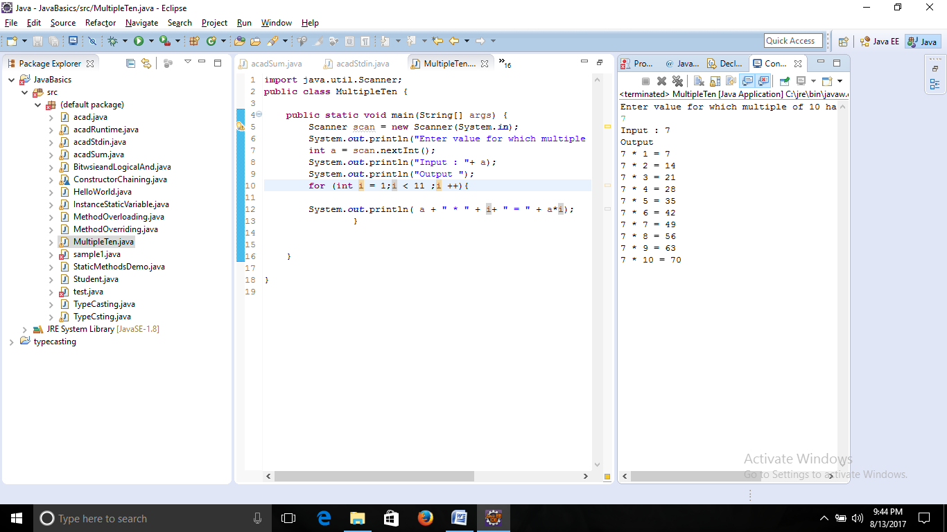

6. Method Overloading

class Sum{

public int Sum1(intx,int y){

return(x+y);

}

public int Sum1(intx,inty,int z){

return(x+y+z);

}

}

public class SumOverloading {

public static void main(String[] args) {

Sum obj = new Sum();

System.out.println(obj.Sum1(10,20));

System.out.println(obj.Sum1(10,20,30));

}

}

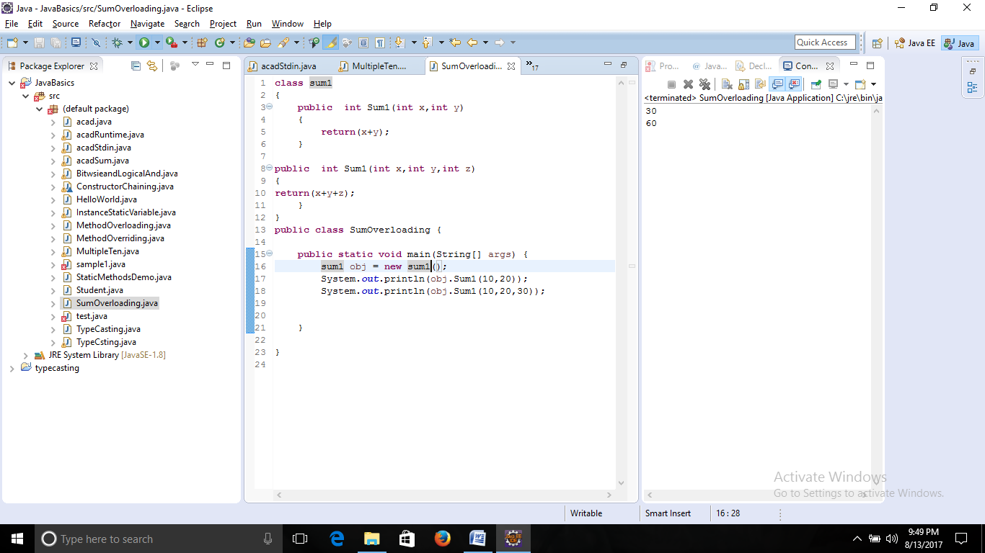

7. Yes we can overload a method with same return type. The above example clarifies it.

8. Sort elements of an array in descending order.

importjava.util.Scanner;

public class SortArrayDesc {

public static void main (String[] args) {

intn,temp;

Scanner scan = new Scanner(System.in);

System.out.println("Enter the no of elements in array");

n = scan.nextInt();

int a [] = new int[n];

System.out.println("Enter all the elements :");

for (inti =0;i < n; i++)

{

a[i] = scan.nextInt();

}

for (inti =0 ;i<n;i++)

{

for (int j = i + 1;j < n; j++)

{

if ( a[i] < a[j])

{

temp = a[i];

a[i] = a[j];

a[j] = temp;

}

}

}

System.out.println("Descending Order :");

for (inti = 0; i< n - 1; i++)

{

System.out.println(a[i] + ",");

}

System.out.println(a[n-1]);

}

}

